Types of Sentences

Sentence Types by Function
# Source: AI Source: Provided by: [Data Path: Persons Table -> ID Column: 1, Name_En Column: Motasem Essam] -> From: [Chatgpt (GPT-4-turbo)] on [7/28/2025]
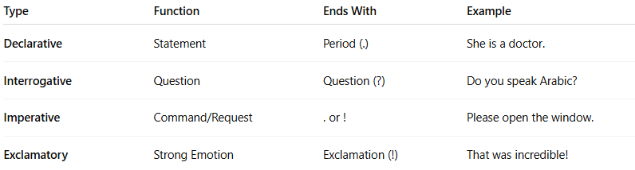

Type | Function | Ends With | Example
Declarative | Statement | Period (.) | She is a doctor.
Interrogative | Question | Question (?) | Do you speak Arabic?
Imperative | Command/Request | . or ! | Please open the window.
Exclamatory | Strong Emotion | Exclamation (!) | That was incredible!

Sentence Types by Structure
# Source: AI Source: Provided by: [Data Path: Persons Table -> ID Column: 1, Name_En Column: Motasem Essam] -> From: [Chatgpt (GPT-4-turbo)] on [7/28/2025]
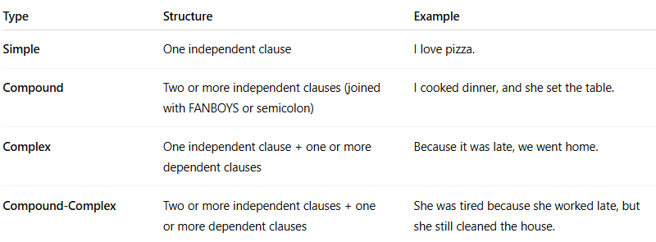

Type | Structure | Example
Simple | One independent clause | I love pizza.
Compound | Two or more independent clauses (joined with FANBOYS or semicolon) | I cooked dinner, and she set the table.
Complex | One independent clause + one or more dependent clauses | Because it was late, we went home.
Compound-Complex | Two or more independent clauses + one or more dependent clauses | She was tired because she worked late, but she still cleaned the house.

